**Writeup for Alien’s Message:**

Challenge contain audio.wav file, on analyzing that file we can get to know that it contains some glitchy sound.

Maybe audio is being glitched or something is embedded in that audio.

On trying steg tools on it, we get to know Flag is being embedded in audio using Audio LSB method on decrypting that we get Flag

We can get Encoding and decoding algorithm of Audio LSB online anywhere.

Searching and applying that algorithm we can decrypt the flag from Audio.

decrypt.py

import wave  
song = wave.open("audio.wav"**,** mode='rb')  
frame_bytes = bytearray(list(song.readframes(song.getnframes())))  
  
extracted = [frame_bytes[i] & **1** for i in range(len(frame_bytes))]  
string = "".join(chr(int("".join(map(str**,** extracted[i:i+**8**]))**, 2**)) for i in range(**0,** len(extracted)**,8**))  
decoded = string.split("***")[**0**]  
  
print("Successfully decoded: "+decoded)  
song.close()

We get this output.

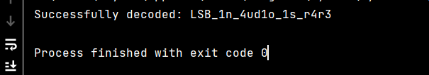

Wrapping above string into Flag format we can get Flag.

Flag: vishwaCTF{LSB_1n_4ud1o_1s_r4r3}